**Thomas Martin**

**CS-470-18332-M01 Full Stack Development II**

**4-4 Assignment: Testing Lambda and Gateway API**

**Southern New Hampshire University**

**November 23, 2024**

Screenshot of the GET method execution page

Screenshot of the browser running the URL

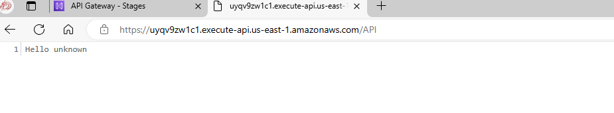

The invoke URL from your deployment

